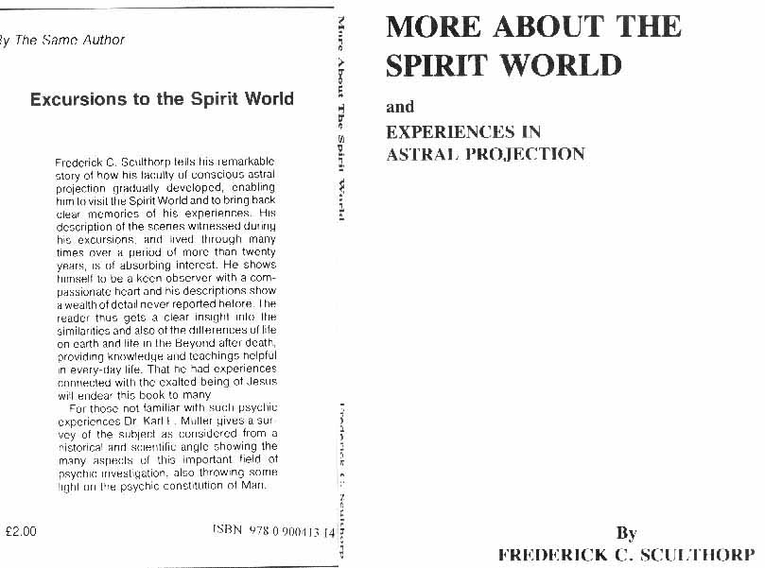
first published 1975 via the greater world association trust. Book is out of print and I scanned "this last copy" that was available as a used book. Link to his ‘main-book’, (or dk-translation link - eller som dk-lydbog)
illustrations here below and elsewhere> were not in that original book. Book here formatted for A4

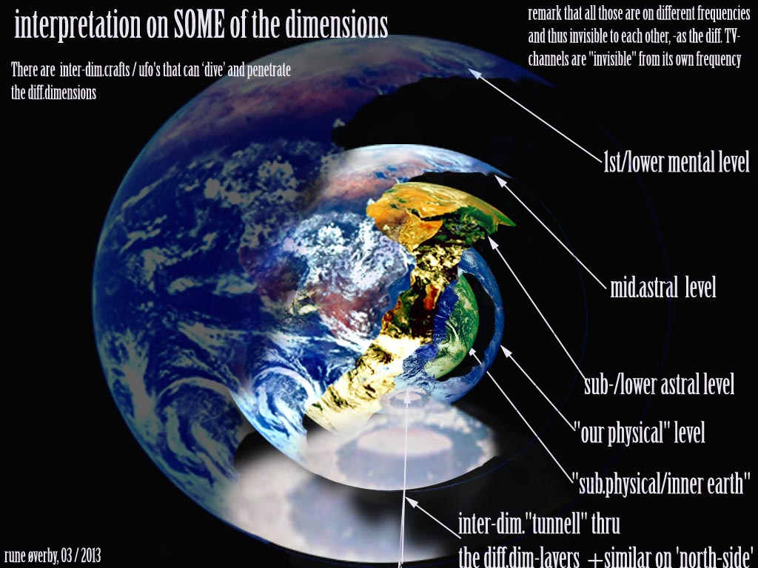

FOREWORD
We sometimes read accounts of people under an anaesthetic during an operation, who have found themselves floating over their physical bodies and even visiting other parts of the hospital, then, on regaining consciousness, have related certain incidents and had them corroborated by those in attendance.
This free floating body, composed of certain elementary particles and invisible to physical sight, is the spirit body and is not affected by gravity.

It is the inheritance of humans and all living things; there are no exception. "To-day thou shalt be with me in Paradise!"

I have had these experiences in this floating or they were not haphazard, but were conducted by a gende and spiritually advanced man who lived during the Ming Period. Like all who are in the higher planes of Spirlt, he is under the leadership of Christ.

Apart from a few earthly expedriences, my travels were to the Spirit world and I have written about them in the book Excursions to the Spirit World -for ca 60years+ back. Or dk-translation link)
This booklet consists of articles I have written from time to time, and explains certain happenings more fully.

I hope it will be helpful to many, especially to those who have experienced the dreadful sadness of losing a loved one, as I have done.

"Blessed are those that mourn" - I used to wonder what this meant. I know now, for mourning is love, and love is the greatest of God's laws, and in my case provided a link and I was blessed beyond my wildest dreams.

Nothing is lost, for Spirit is timeless, and the past is present between loved ones who, "wonder of wonders," remain in the prime of life.

I am not a churchgoer - the compulsory church parades in the army during the first world war, and the absence of any trace of brotherly love quite put me off. There are many gentle ones in the Spirit realms who work with the help of the Master. Just ask for your spiritual needs you know how.

FRED. C. SCULTHORP,
Jones House,
Bentham, Cheltenham.

ASTRAL PROJECTION
I have now experienced astral projection for over 30 years, and as all the travels, except for a half-dozen or so, were to the Spirit World, it has given me a little knowledge of spirit life and an inward happiness because all life continues. No yearning for reunion is unanswered, even with our animal friends. Some may think that in the intervening period before the reunion in spirit, something has been lost, or perhaps that loving companionship has waned with the years. That is not so. All memory is contained and held in the spirit body which encompasses the physical body on earth. The physical brain is simply the "detector" (in the electronic sense) of that memory, and as we all know, age can dull that physical organ.

In the sensitive spirit body memories of the past are there with all the details, and there is no physical impediment, therefore "the past is present." To emphasise the significance of this, "time" as we know it is absent, and the companionship continues, but with intensified happiness because love emanates from the surrounding auras of two spirit friends meeting, causing the further upliftment of both. The spirit message we often hear, "I am very happy," can mean more than the actual words convey, as I very well know.

Many on earth with the desire for knowledge will later be amazed at the wonderful effects of the spirit laws, if they are willing to listen to the spirit teachers.

What the Master taught (and He lived according to His teaching) can be better understood and with this understanding the mentality becomes clearer and open to further knowledge.
The increase of knowledge of physics, radiation and electronics is helpful and the physicists know that everything has a rhythmic pulsation or vibration of different frequencies.

It is hard to define the borderline of physical and spiritual. The coloured butterfly which finds the buddleia blossom, or the moth that can find its own species
even miles away, can be an up-wind sensing of molecules, yet one must realise the delicacy of the antenna and the sensing of the rhythmic frequency of the molecules.
I have found that in the spirit world water can flow, is buoyant, and can be drunk, but it does not wet my spirit clothes if I enter it. (similar told in this book at page 14.)

The free particles of all atoms gravitate to the magnetic belt surrounding the earth and form the familiar localities and countries which one sees in the first spirit planes. As they are of different atomic structure, all places on earth have a different frequency of vibration, and this is so with the counterpart of the localities in the Spirit World.

A person passing over from this country would not go to a Chinese or South American part of the Spirit World, as the spirit body is inured to the vibration frequency of his own country. An analogy is the mystery of the adult salmon which, even from a vast ocean, is drawn back to the same river of its spawning. It is simply because no other place has that frequency of vibration. Let us hope that the search for knowledge flows over the border from the physical to the spiritual. I have before me a cutting taken from the "Daily Telegraph" some time ago.

"By Our Science Staff"
"The announcement of the American Atomic Energy Authority of the discovery of the Anti-X1-Zero particle is of particular interest to astronomers. . . . The idea of anti-particles gives rise to some fascinating possibilities. It is quite conceivable that there might exist a kind of looking-glass world, in which 'all matter is made up from anti-matter. Life in such a world would be exactly the same as ours. For all we know such a world might well be in the far-distant parts of the universe."

HAPPY REUNIONS IN SPIRIT
(Although the spirit body feels normal and "solid" it is composed of elementary (electric) particles, and immediately responds to thought. A progressed spirit can travel, when needs be, at great speed.)
I had projected at night and was taken to a bright plane in spirit, which denoted a progressed state. I was alone on a vast grassy plain, and as I waited expectantly and looked at the beautifully clear surroundings, I saw two pin-points of light far away in the distance.
They seemed to get brighter and then suddenly became two brilliant orbs of blue-white light which were travelling towards me at a tremendous speed. Before I had time to be startled, they stopped before me and became two young men. They were two of my army companions of the 1914 war who had passed over and made good progress in spirit.

Their appearance was very fine and bright and I sensed their extreme happiness in meeting me and their thoughts contained a wonderful flood of benevolence and companionship which rather touched me. I in turn was also tremulously happy to see them which no doubt they also sensed, and we excitedly recalled our former times together on earth.

We chatted for a while and then said "Goodbye" and as they started to go, one suddenly turned back and kissed me on the cheek, and then rejoined his companion. I was not surprised - I knew that his progressed state held the sincerity and tenderness of real brotherhood and the kiss meant more than he could express in words.

Much happiness is felt in the sensitive spirit body when meeting friends in spirit. In this meeting, when I saw my companions, I was naturally happy to see them and radiated that thought. In turn, my friends' pleasure in seeing me, emitted a similar thought which infused my spirit body with further friendship towards them. This interchange of thought passes back and forth with mounting intensity and speed and is cumulative, so much so that all the dross of earth life is forgotten and I felt intensely happy to be with them.

This is the spirit effect of God's laws, for what is given out is returned a hundredfold, and the feeling of companionship and closeness was much greater than we ever felt towards each other on earth.
How much more so does this law take effect when meeting one's marriage partner in spirit?
'Zodiac says in "Marriage and the After-Life": "True it is that there is no 'marriage' in the bright spheres but there is a unity between soul and soul which far transcends anything that has ever been experienced, even under the most ideal conditions upon earth." ("The Greater World," January 12th, 1963.)
What is it that "far transcends" anything on earth?
In the earthly body it is difficult to imagine the finer sensibility and feeling that pervades the spirit body, and after many years of experience of life in the Spirit World, I find it equally hard to describe it.
If meeting my army companions in spirit gave me such happiness, the reunion with my wife in spirit was certainly beyond all earthly happiness. In the mingling of auras we knew one another's thoughts, and there was a blend of affection which was far beyond earth and biological reasoning. The union of tender and sincere thoughts made us good "conductors" to the influx of the ever present "God stream"-it was almost overwhelming, and we wanted nothing more than the bliss of one another's company.

Spiritual things must be spiritually discerned and spiritual feeling can only be felt in its fullness in the spirit body. An earthly analogy-if one is moved by a beautiful melody, would be to imagine that feeling magnified a thousand times and shared by one's beloved.
"And when they come Home, they will find their loved ones waiting for them, and in that reunion - which means a unity, which is impossible to explain in words, because it is of the Spirit and not ‘of the body-joy’ and perfect happiness becomes their own." (Zodiac.)
(The teacher from the Spirit World, "Zodiac," quoted at times, is the one mentioned in St. Mark's Gospel, 12, 28-34. He spoke through the mediumship of Winifred Moyes from 1921 to 1951.)

A TEA-PARTY IN THE SPIRIT WORLD
(Lovely people-lovely children-and a lovely party. And
to book lovers, a hint of future joys.)
I had projected during the night and met my wife (who had passed over- see first book) in a house full of ladies. As well as the great happiness, as in all our meetings, it was very pleasant to be with these people as it was a progressed plane. All the ladies were busy, and I sensed the preparation for party or celebration. A newcomer entered, a lady with basket containing a parcel, and someone said, "It's the Queen," but I did not recognise what past queen she was,
I went with my wife to another room, and presently she said she would help the others to prepare some dishes. Left alone, I saw a book on a table and sat down and casually turned the leaves.
this could, for example, be on the subtle, so-called spiritual level>
The book dealt with furniture, flower arrangement, etc. of a home in spirit, and the position of windows and their outlook. As I saw the illustrations and read the paragraphs, I became enveloped in a strange happiness - a warm welcome - and I realised that my sensitive spirit body was psychometrizing all that the spirit author had impressed on the book. The picture of a comfortable room would emit a wonderful warmth of welcome. A window would become a panorama of beauty, showing sunny lawns bordered by flowers, while the mind of a great friend seemed to draw one to share its beauty with him. My casual look at this apparently ordinary book had turned to a delightful happiness - in fact, I almost lived in it! I suddenly sensed the presence of my wife and looked up.
Knowing my interest in books, she had turned back see the effect it had on me, and stood smiling. I said to her "What a wonderful book. I wonder if I could get one like it?" "You will," she said. I got up and we went into the room where the others were, then I lost consciousness. (Consciousness often waxes and wanes during a projection, but the "higher self"-the finer spirit body - still carries on.) Becoming conscious again, I found that the "tea-party" was nearly over and I was finishing a trifle of fruit and jelly, which was rather nice. We all went to another room where there were about 20 tiny children. The eldest I should think could not have been more than three years old, and he sat in a group on the floor with the smallest ones in front. I noticed that several of these small ones had a delicacy of features and a tint of clothing that was ethereal and "different" and I had the impression that they were stillborn babies.
My wife began to tell them a fairy story. Then followed what was, to me, one more delightful experience of a happy state in spirit.

These children were very beautiful and their little faces were upturned and rapt in a happiness of wonder and delight as the tale unfolded. On this plane the mind of the storyteller has greater clearness and scope which can envelop their little minds with unspoken beauties, and even mental pictures connected with the fairy tale. When the tale ended my wife said to them, "Now we will go into the next room to see the fairy's treasure"-and they went off happily singing a nursery rhyme which I had not heard before, but it was a happy tune and beautifully sung, as is usual in spirit when minds are in unison.

The children returned, still happily singing, but I began to lose interest, my time was up, and I returned to the bed and switched on the light. As I looked at the clock- it was near 2 a.m.- I was impressed about something concerning the date. I thought for a few seconds; it was April 24th, my wife's birthday, and so the well-kept secret was out - it was her birthday party!

Later, a medium friend said to me, "Do you know that you tell fairy stories to spirit children?" I did not know it, but I am certain my wife does!

(Note: Psychometry is handling an article and sensing the thoughts of the owner. The ultra-high frequency of the owner's thought emissions causes an induction, which is held by the article.)

CHILDREN IN SPIRIT
She was a little girl of about ten years of age and as we walked, I had my arm around her and my hand on her shoulder. I thought her dress (spirit robe) was rather long, but I was upset when I saw that she had bare feet.

As I had "mothered" my two little girls, when my wife passed over, I felt sorry for her shoe-less state. But I need not have worried, for the little girl had the situation well in hand. She was leading me on my first conducted tour of the Spirit World.
Zodiac has often spoken of the work the spirit children do, and some may wonder how a child can help an adult with a lifetime of "knowledge." As the spirit body retains all life's thoughts (one can ponder over the millions of thoughts in an adult mind) to deal with a situation, the past memory is probed for that knowledge, and the solution, when found, is probably an earthly one!

A child, who passes over at a very early age, has not this mass of thought, and in its innocence has a spirit body that is appropriate to a higher plane or wavelength in spirit.
As the plane and its people are advanced, everything it learns is truth and in its innocence accepts everything and speaks truth. It forms a lovely personality devoid of fear, worry or doubt, and to be close to the aura of such a child gives one a feeling of serenity and quiet happiness.
One Sunday afternoon, I had projected from an armchair and was taken to the bright countryside in spirit with park-like scenery of trees and grassy slopes. I saw several people sitting on a bench and I went and sat next to a little girl, who was sitting close to a man. I sensed that she had spent most of her life in spirit, and she began to talk to me. She was a lovely child of about seven years of age and spoke simply and clearly, and in her conversation mentioned Jesus.
As our auras were mingling, I sensed a connection and asked her if she had seen Jesus lately. In a quiet matter-of-fact way she answered, "No. He is now on duty in the East." (It was April, 1961.) The man sitting on the other side of the little girl was a neatly dressed office-type, and being with this little girl, I thought he would know quite a lot. I leant forward and asked him, "What do you think of life after death?"
To my surprise he at once stiffened and adopted an earthly conventional pose and replied in a dignified tone, "I do not wish to discuss the matter." I immediately knew that he was one of the many still living in a dream world, or what has been called "The Plane of illusion." He did not know that he had "died" and was now in the Spirit World, and the little girl was patiently waiting for an opportunity to help. I tried to think of some possible line of talk, despite the rebuff I saw a movement beside me, and turned.
A lady, who was sitting by my other side, was rubbing her brow and seemed to be thinking deeply. She murmured as if to herself, "That's strange. Now I come to think of it, the river Exe Devon> doesn't look the same." My journey arranged by my spirit helpers was evidently not altogether fruitless, as my thoughts had some effect on the lady. It is rather strange how those still connected with earth (like myself) can sometimes bring enlightenment to a spirit, and in a rescue circle it will be noticed that a spirit brought for her, will often become conscious of the new state by simply contacting the thoughts of the people in the circle.

Spirit children are often taken on sight-seeing tours in the Spirit World, and on one occasion I was out-of-the-body and with my daughter who has passed over. We were watching a long line of these children. They looked the same as children on a school outing, and I picked up one little girl and said, "And where have you come from?" and she said, "Venezuela."
I asked her, "Are you tired?" Her eyebrows went up in bewilderment. "No," she said.
My daughter was laughing. It was a silly question, as I knew there was no physical tiredness in spirit, but my earthly thoughts immediately connected such a journey with fatigue, hence the child's surprise.

PERSONAL INTERESTS IN THE SPIRIT WORLD
During astral projection to the Spirit World I have seen many of the earthly interests of people still being enjoyed. In the bright states these are only part-time, as that state is only reached by helping the others less progressed. It is God's law that in helping the welfare of another, "self' is absent and is replaced by the purer God power, and this the Master taught in various ways.

I have previously mentioned my daughter in Spirit who on earth enjoyed horse-riding, and still does so in the Spirit world. At other times she teaches children and classes of young people. My father enjoyed his garden on earth and on one projection he showed me a room in his house in spirit that was full of flowers like a greenhouse. It looked beautiful as the walls seemed to admit all light. On one occasion I was helping him to prepare the garden of a house in spirit for a newcomer.
on the astral plane you can safely ride without a helmet, as the body there cannot be injured as ‘here’, for example, in a fall from the horse. And regarding animals on the astral plane, it is interesting to read from part 5 of the book "Seven Steps To Eternity" by Stephen Turoff (rune rem.)

I said to him-"and we can hide that shed with a row of runner-beans." He was very amused and I realised that there were more colourful flowers in spirit than scarlet runners.

There are orchestras and brass bands in the spirit world and I have played an instrument, and have found it much easier as the fingers respond at once to thought. I should think that it is easier to learn an instrument in spirit as the mind is clearer and retentive.

I have seen and enjoyed small boat sailing, and there are also ball games. In some bright states, however, one can direct a ball by thought, so there would be no point in having a competitive game. My spirit teacher once took me to a lower state where there were people watching a football match.

When the ball narrowly missed the goal, I said to the man near me, "That was close," and he agreed and seemed pleased to be spoken to. With my attention on the game again, he edged closer and entered my aura, and I sensed he was a pickpocket! I felt a slight touch towards my coat pocket and I said, "You won't find anything there." Immediately the nimble fingers were withdrawn and were fondling the lapel of my coat, and quite unabashed, he was saying, "I used to have a suit like this." This is the mentality and ignorance that enters the lower states, and one wonders with sadness as to what possible way of approach can be made to help. I visited a park in a pleasant state in spirit which has several buildings which many people were entering. Each building had something of interest, including all the art mechanical, printing, etc. One small building had a narrow circular canal which ran through one side and out the other Inside there were boys playing with model boats, and I said to one boy who was watching his model liner sail by, "What makes it go?" "Vibrations," he replied with gusto and was evidently glad to see them as they are a cheerful couple, and they were pleased to see me. But the meeting had been arranged, for they presented me with an ebony walking stick! (It was a sign that they knew that walking now tired me on earth.) It was also another spirit lesson for me for when I left them I still felt the pleasure of their friendship and company, and I realised that my sensitive spirit body had a continuous psychometric impression of their personalities in the stick I was carrying! This is another pleasure we can look forward to in spirit-a present always carries a reminder of the donor's personality.

THE MIRACLE OF SPIRIT AND MATTER (1)

"Everything in physical life has its spiritual counterpart."-ZODIAC.

During astral projection to the spirit world I was once talking to one of the teachers, who drew my attention to my clothes. I saw I was wearing my usual suit; it even had a small stain on it, the same as its earthly counterpart!

All atoms have "off-shoots"; electric particles which have the same vibration as the parent atom and therefore the same "sensation" or property, but in non-physical form. So even the stain had to conform and have its replica of off-shoot particles. The significance and magnitude of this must be realised, as a grain of sand has its spiritual counterpart, therefore the desert, countries, continents, seas, means everything! This spiritual counterpart has no weight and is not affected by gravity, but is held by the magnetic zone surrounding our planet. During astral projection the magnetic zone (aura) of my spirit body attracts the spirit counterpart of my earthly clothes, because they hold my personal vibrations.
All is vibration.

Different localities and countries have different atomic composition and mass and therefore different vibrations. Racial minds have their certain "traits" which is also a vibration, but it
is not generally noticed by the slower physical senses. The spirit body is very sensitive and during a projection to the spirit world, two unprogressed and sadly deformed people were brought to me, and I knew their nationality by their emissions (vibrations).

The ultimate basis of spiritual and physical things is elementary particles. Free elementary particles of different frequencies (fine or gross) also permeate all space. (Some physicists say 100 to the cubic centimetre.) In the unimaginable vastness of endless space, in which our Earth and Sun are mere specks, there is enough "material," if concentrated, for many new worlds. ("Zodiac" denies the astronomers' theory that the earth and moon were thrown off from the Sun.) In the spirit world spirits can form spiritual things by the concentration of positive thought (electrical activity) on these negative free particles, thus bringing them together.

I have been in the lecture rooms in the spirit world where many subjects* are taught, and spiritual science is only one of them and is for those who wish to know. However, having a knowledge of spiritual science or not, those good souls who empty themselves of "self" and extend friendliness and help to others, find that their "giving" is replaced by further powers and a pure happiness. When I have been taken to them in the bright planes I have felt their radiations, and it seems that by their friendliness they have become "good conductors" to that God-stream of power, the greatest law of spirit and simple too, "Love one another."
*the same is told in the book through the curtain.r-rem. (or dk-ed. Audio-dk)
The Man who entirely eliminated "self" had a love and compassion for others to such an extent that He and the God-stream are One. In His earthly life His mysterious miracles were for all to see, but His teaching was simple. The instructions are still simple -
too simple for the wiseacres, but they are true and direct, and if all acted upon them there would be an accumulated and unhindered stream of power that would transform the world.

Many years ago when I was "seeking," He once told me that He was "in charge" of our world. I treasure the memory of His presence and His simple statement, for like the sparrows, even I and all of us are "known."

THE MIRACLE OF SPIRIT AND MATTER (2)
("Homing," which is a mystery to biologists and other scientists, is no mystery in the spirit world. A spirit can easily "home" on to his old earthly residence, and to loved ones on earth-there are no Sign-posts in Spirit.)

How did the dove find its way back to the ark? Its home was mobile and not localised! It is a Bible story, but the peculiar homing happens to-day. A pigeon fancier related the following:
A man in London bought a pigeon from one in Staffordshire. He kept it for a time in his pigeon loft, but when released it did not return. He wrote to the previous owner, who said that the bird had returned to him-but, he had moved to Wales. The pigeon had not returned to its previous district, but to its old familiar loft now in Wales! "Zodiac" often mentioned "vibrations" and it is often the subject of lectures in the spirit world.

All is vibration. Solids, liquids and gases have different vibrations in the atoms composing them. Our God-given senses can recognise different foods and liquids by the frequency of the vibration of their atomic composition. The same applies to light rays; different frequencies have different colours. Our senses can detect the invisible free floating molecules forming odours which, too, have their vibrations. Everything has electrical association; the atoms with their electrons, our bodies composed of atoms, and our nerves conveying the vibration or "sensation" to the brain.

The electrical activity of the mind can be recorded by an instrument and contact, but positive thought has a frequency of many millions and far beyond the sensitivity, of an instrument yet made. If such a thought has "desire, as in telepathy, the radiation is far-reaching, even penetrating mountains and the curvature of the earth as if they were non-existent.
The pigeon previously mentioned, whose personal vibrations were already impressed on its old loft, radiated a yearning thought for "home"- contacted it and thus found the direction.

Some years ago a daily paper reported the incident of a farmer in Devonshire who took over a farm in Scotland, taking his cat with him. In four weeks the cat returned to its old home "very much the worse for wear." This was no haphazard wandering and the route must have been direct for such a journey. A London evening paper had a brief report headed "A Mystery." A cow whose calf had been taken and sold at a cattle 'market, got out in the night and found its young one. It was on a farm 30 miles away. On its journey it had to cross the river Thames - "no one knows where!"
The loving mother had yearned for a very personal belonging - her treasure and found it. I have often wondered if they were allowed to be together again, if only for a time.
Another vibration in the "Miracle of life and spirit."

IF THEY ONLY KNEW !
After living a double life for over 30 years (sounds like an old lag's confessions in a Sunday paper) I have often been saddened by a casual expression, a paragraph I have read, or something mentioned on the radio. My "double life" is the continual visits I have made to the Spirit World where the results of our earth life are plain to see.

I have just heard on the radio ("What The Papers Say") that better organised bank raids, etc., and the technology, can even be learnt by these men in prison, who prove that crime does pay. All crime is paid for. The reporter who seemed to admire this "skill" will later be appalled by his earthly ignorance.

The minister of a small church spoke about his shrinking congregation - sometimes only three or four attending - and said that his living really came from the people of the past who left money to the church and who are now "sleeping in the churchyard." If the minister had shed some of his theology and in his heart "became as a little child" he would find that the Master will amply reward his "seeking." And if he finds that there are no sleepers in his churchyard, but active and friendly people in their new life, willing to come and help him he could teach this in his church and lift the hearts of many.

If his "sacrifice" causes a few lifted eyebrows, the cross in his church should remind him of that greater sacrifice and the hatred and jeers of proud priests of that time.

The news today seems to be a repetition of robbery, violence and vandalism, all of which will have to be paid for later in the dreary twilight states, and I have seen no clever ones who have "got away with it."

It is not news, but it is a fact that the great majority of people in our country are well - ordered and friendly, and many are surprised on entry to the next life.

The unnoticed (so she thinks) mother who has attended to the home, the many cares of the children, the family wash and that ever recurring "washing-up" has done something for others. She does not think of reward or even thanks. She has done something without thought of self, which is the great law of spiritual progress. The Mary's and Martha's are blessed!
Money, fame and titles have all gone and those who have grown into the habit of privilege have many adjustments to make. Only the real and personal character is left. If only they knew!

"JOE MORLEY"
My "excursions" to the spirit world are not often now, but not long ago I had an experience that gave me pleasure and was also surprising and evidential. Years ago there used to be a concert player, Joe Morley. (1867- 1937.) He was a solo banjoist and I had seen him at Kensington Town Hall, and he also played at
<Wigmore Hall and other places. He was well known and very popular among the fretted instrument players, both for his playing and his many compositions. Morley passed over some years ago (1937) at a good age.

One afternoon from my armchair and out-of-the-body, my spirit teacher took me to see Joe Morley in his spirit life. Morley never knew me on earth, (I was just one in the audience), but the meeting gave great pleasure to both of us and he was beaming all the time. I like these happy meetings in spirit, for when the auras intermingle the pleasure is reciprocal and greatly intensified far more than earthly feelings. Although he was old when he passed, he now looks 35-40, with the healthy looking and fine features of spirit. Before I left him, I congratulated him on one of his fine compositions, "El Contrabandista," and said, "I suppose you often played this at concerts," and Morley said, "No, I never played it publicly."

This surprised me, and later I wrote to the Assoc. Editor of "B.M.G." >

(the monthy magazine for Banjo, Mandolin and Guitar) asking if he or any of his friends had ever heard or known Morley play his own composition, "El Contrabandista." He replied, neither he nor his friends had known him to play it. I thereupon told him the reason for my enquiry and my meeting with Joe Morley. He very kindly gave a full account of my experience in the February issue of "B.M.G.," which I hope gave pleasure to those who knew this old player, and to the spiritually younger Joe Morley.

AN EXPERIENCE IN ASTRAL Projection
(This is a strange experience. Zodiac tells us that the human spirit was created in God's Image, and that animals are a separate creation. This gentle human entity apparently never incarnate, and from another plane in spirit, may have used or controlled the spirit body of the foal in order to learn with the children, in preparation for earth life.)

Note: My wife's parents and their forebears were country people. Her father had a lot to do with horses, and when they came to live in London, he still kept his own horse. He was a kindly man, but was not interested in Spiritualism, and passed over with no knowledge of spirit.)

Out of the body, I became conscious in the back room of a big old farmhouse. I was with Doris, my wife, who had passed over, and sensed that it was the home of her father in spirit. Doris asked me to bring in a saddle which was hanging outside, and I took it into a part of the house which was the big living room. Inside, I saw her father, and also to my surprise, there was a young foal which was walking about the room. It was a lovely creature and although long legged, was well formed and had beautiful eyes.

When I went forward it turned and saw me, and my appearance startled it and made it restless. However, as is usual in spirit, it at once received my friendly thoughts and was quite calm when I stroked its fine silky coat. My father-in-law told me that he was looking after the foal and it had become a sort of household pet.

I spent a considerable time, the whole projection, in and around this house, with many periods of consciousness waxing and waning, and was often with this beautiful animal, and it also seemed to like my company. Now comes the strange part of my experience. …

continues later

